Advanced JUnit Testing Exercises

Exercise 1: Parameterized Tests
Scenario:
You want to test a method that checks if a number is even. Instead of writing multiple test cases, you will use parameterized tests to run the same test with different inputs.
Steps:
- Create a new Java class `EvenChecker` with a method `isEven(int number)`.
- Write a parameterized test class `EvenCheckerTest` that tests the `isEven` method with different inputs.
- Use JUnit's `@ParameterizedTest` and `@ValueSource` annotations.

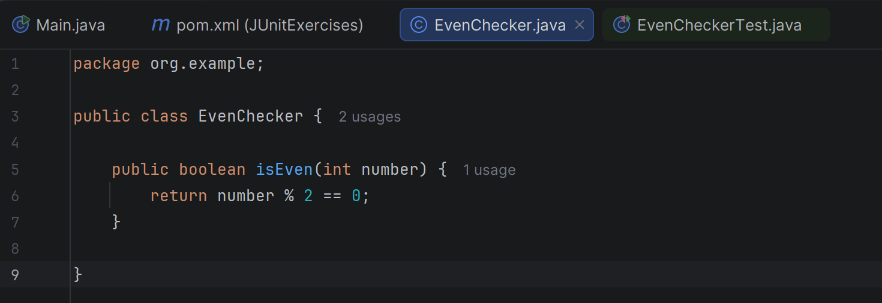
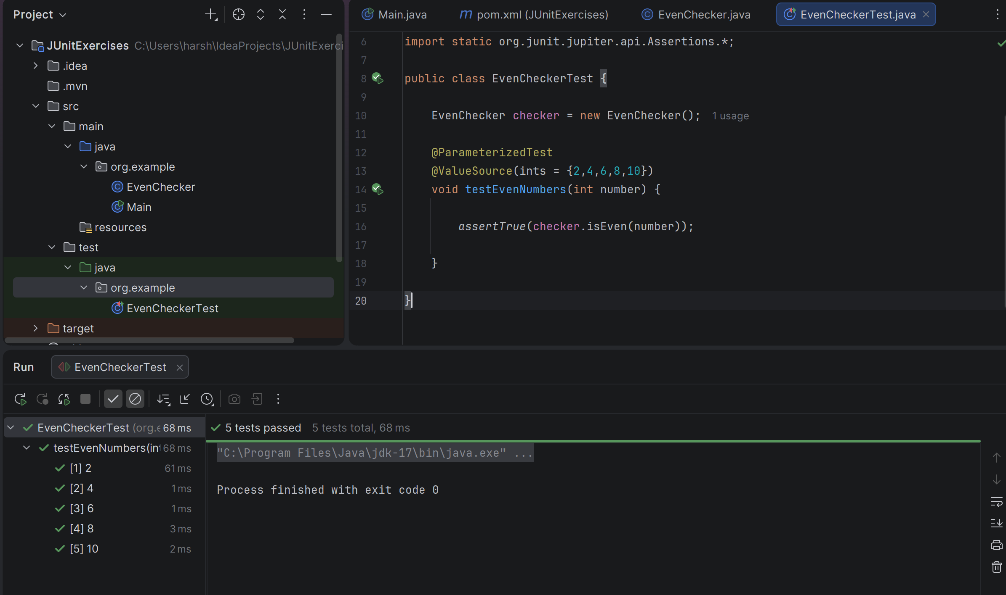

Exercise 2: Test Suites and Categories
Scenario:
You want to group related tests into a test suite and categorize them. Steps:
- Create a new test suite class `AllTests`.
- Add multiple test classes to the suite.
- Use JUnit's `@Suite` and `@SelectClasses` annotations.

Exercise 3: Test Execution Order
Scenario:
You want to control the order in which tests are executed. Steps:
- Create a test class `OrderedTests`.
- Use JUnit's `@TestMethodOrder` and `@Order` annotations.
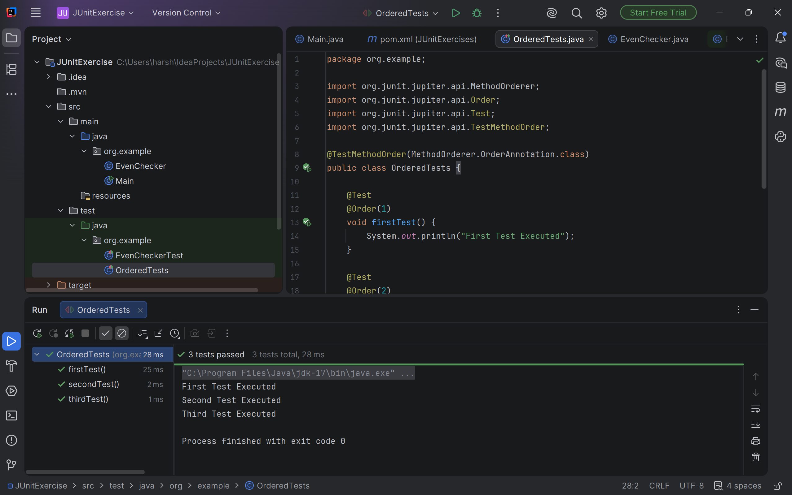

Exercise 4: Exception Testing
Scenario:

You want to test that a method throws the expected exception. Steps:
- Create a class `ExceptionThrower` with a method `throwException`.
- Write a test class `ExceptionThrowerTest` that tests the method for the expected exception.
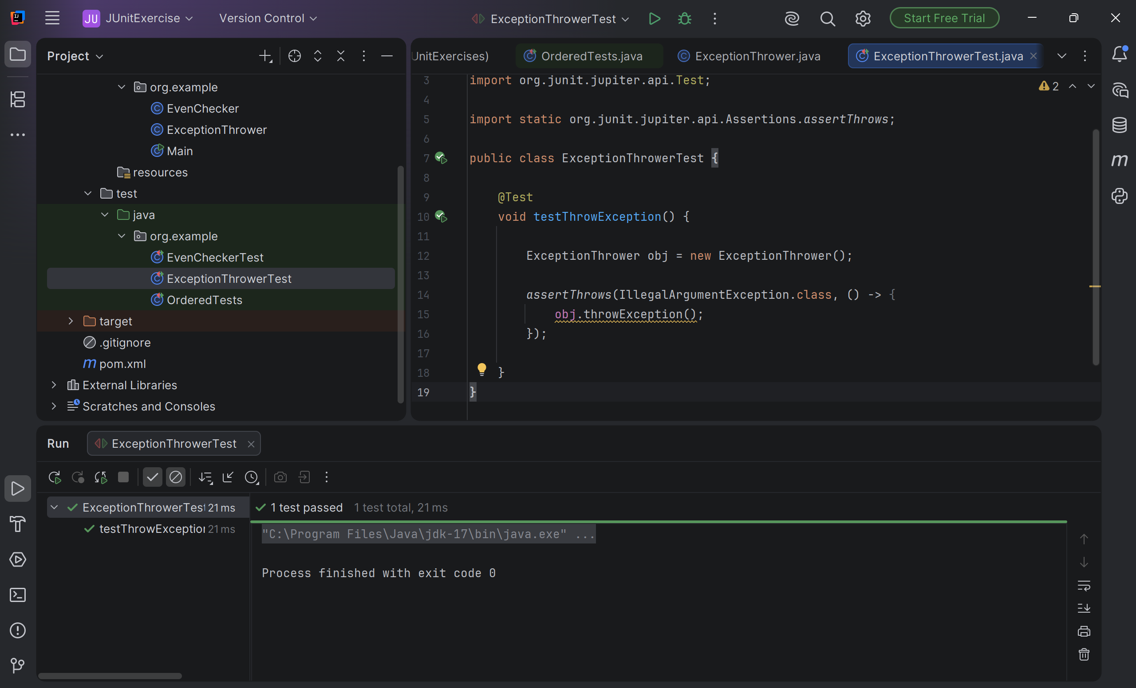

Exercise 5: Timeout and Performance Testing
Scenario:
You want to ensure that a method completes within a specified time limit. Steps:
- Create a class `PerformanceTester` with a method `performTask`.
- Write a test class `PerformanceTesterTest` that tests the method for timeout.
